**CHAPTER 1**

**INTRODUCTION**

**INTRODUCTION**

**E-COMMERCE**

E**-**commerce is the activity of buying or selling of products on online services or over the Internet. Electronic commerce draws on technologies such as mobile commerce, electronic funds transfer, supply chain management, Internet marketing, online transaction processing, electronic data interchange (EDI), inventory management systems, and automated data collection systems.

Modern electronic commerce typically uses the World Wide Web for at least one part of the transaction's life cycle although it may also use other technologies such as e-mail. Typical e-commerce transactions include the purchase of online books (such as Amazon) and music purchases (music download in the form of digital distribution such as iTunes Store), and to a less extent, customized/personalized online liquor store inventory services. There are three areas of e-commerce: online retailing, electronic markets, and online auctions. E-commerce is supported by electronic business.

**E-BANKING**

Onlinebanking, also known as internetbanking, is an electronic payment system that enables customers of a bank or other financial institution to conduct a range of financial transactions through the financial institution's website.

The online banking system will typically connect to or be part of the core banking system operated by a bank and is in contrast to branch banking which was the traditional way customers accessed banking services.

Some banks operate as a "direct bank" (or “virtual bank”), where they rely completely on internet banking.

Internet banking software provides personal and corporate banking services offering features such as viewing account balances, obtaining statements, checking recent transaction and making payments.

**E-PAYMENTS**

An e-commerce payment system (or an electronic payment system) facilitates the acceptance of electronic payment for online transactions. Also known as a subcomponent of Electronic Data Interchange (EDI), e-commerce payment systems have become increasingly popular due to the widespread use of the internet-based shopping and banking.

**KOTAK MAHINDRA BANK**

Kotak Mahindra Bank is an Indian private sector bank headquartered in Mumbai, Maharashtra, India. In February 2003, the Reserve Bank of India (RBI) issued a licence to Kotak Mahindra Finance Ltd., the group's flagship company.

It offers banking products and financial services for corporate and retail customers through a variety of delivery channels and specialized subsidiaries in the areas of personal finance, investment banking, general insurance, life insurance, and wealth management. As of April 2019, it is second largest Indian private sector bank by market capitalization.



**OBJECTIVES OF MY PROJECT**

1. To study about investments and loans given.
2. To study about E-paymemts system.
3. To study how kotak bank is helping the public in economic development.
4. To study customer satisfaction level.
5. To study about advantages and disadvantages of kotak bank.
6. To study about impact of kotak bank in public.

7. To study about technical issues on security or safety.

**METHODOLOGY**

## **COLLECTION OF DATA**

## The data can be collected from primary and secondary sources. The basic premises of my study is primary data .Convenient sample that was representative of the target market was chosen, the respondents were contacted personally and the instrument used for collecting data is questionnaire.

## Statistical Data can be classified into two categories

* + 1. Primary Sources
    2. Secondary Sources

## **Primary Data**

In this research with a sample size of nearly 50 customer’s data will be available in the form of questionnaire collected in terms of different questions influencing the use of e payment system.

E payment is considered as dependent on awareness among customers which will be studied with the help of different independent variable. Only the person who has online banking is taken as study.

## Primary data is collected by using the questionnaire method.

## **Secondary Data**

Secondary data refers to data that is collected by someone other than the user. Common sources of secondary data for social science include censuses, information collected by government departments, organizational records and data that was originally collected for other research purposes.

Collection of information from different kinds of

* BOOKS
* INTERNET
* MAGAZINES
* NEWSPAPERS
* JOURNALS

## The Main sources of Secondary data are combination of information from the internet, research journals and books of the related topic.

**Smaple Size**

Sample sizedetermination is the act of choosing the number of observations or replicates to include in a statistical sample. The sample size is an important feature of any empirical study in which the goal is to make inferences about a population from a sample. In practice, the sample size used in a study is usually determined based on the cost, time, or convenience of collecting the data, and the need for it to offer sufficient statistical power.

In complicated studies there may be several different sample sizes: for example, in a stratified survey there would be different sizes for each stratum. In a census, data is sought for an entire population, hence the intended sample size is equal to the population. In experimental design, where a study may be divided into different treatment groups, there may be different sample sizes for each group.

The Sample size is 50 people.

**CHAPTERISATION**

**CHAPTER 1 INTRODUCTION**

1. Introduction
2. Objectives
3. Methodology
4. Chapterisation

**CHAPTER 2 COMPANY PROFILE**

1. **GENERAL PROFILE**
2. Mission
3. Origin & History
4. Objectives
5. SWOT
6. Unique Achievements
7. Future Plans
8. **FUNCTIONAL PROFILE**
9. Production ( Product Mix, Production Process, Raw Materials Used, Source)
10. Finance ( Last Financial Year Balance Sheet, Source’s Of Finace, Etc)
11. Personal ( Manpower Chat, Recruitment Process, Incentives, T&D Etc)
12. Marketing ( Four P’s, STD, Etc)

**CHAPTER 3 CONCEPTUAL PROFILE**

1. Theoretical aspects of the “concept”
2. Application of the “concept” in the company

**CHAPTER 4 FINDINGS, ANALYSIS AND INTERPRETATION**

**CHAPTER 5 SUMMARY AND SUGGESTIONS**

1. Summary
2. Suggestions

**ANNEXURES**

**BIBLIOGRAPHY**

**CHAPTER 2**

**COMPANY PROFILE**

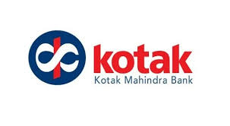

**COMPANY PROFILE**

Kotak Mahindra Bank is an Indian private sector bank headquartered in Mumbai, Maharashtra, India. In February 2003, the Reserve Bank of India (RBI) issued a licence to Kotak Mahindra Finance Ltd., the group's flagship company.

It offers banking products and financial services for corporate and retail customers through a variety of delivery channels and specialized subsidiaries in the areas of personal finance, investment banking, general insurance, life insurance, and wealth management. As of April 2019, it is second largest Indian private sector bank by market capitalization.

**ABOUT SYMBOL**



The symbol of Kotak Mahindra Group is the 'Ka', of distinctly Indian origin; while its curves form the universal 'infinity' sign, thus reflecting our uniquely global Indian personality.

The symbol of the infinite Ka reflects our global Indian personality. The Ka is uniquely Indian while its curve forms the infinity sign, which is universal. One of the basic tenets of economists is that man's needs are unlimited. The infinite Ka symbolises that we have infinite number of ways to meet those needs.

**BOARD OF DIRECTORS**

Uday Kotak

Managing Director & CEO

C Jayaram

Director

Dipak Gupta

Joint Managing Director

Bina Chandarana

Company Secretary

Prakash Apte

Chairman

S Mahendra Dev

Independent Director

Farida Khambata

Independent Director

Uday Chander Khanna

Independent Director

Uday Shankar

Independent Director

K V S Manian

Whole-time Director

Gaurang Shah

Whole-time Director

Kotak Mahindra Bank (the Bank) is the flagship company of the Kotak Group. It is one amongst the fastest growing banks and the most admired financial institutions in India. The Bank offers transaction banking, operates lending verticals, manages IPOs and provides working capital loans. The principal business activities of the Bank are organised into consumer banking, commercial banking, corporate banking, treasury, and other financial services. As of 31st March 2019, the Bank had 1500 branches and 2352 ATMs, covering 744 locations. As at 31st March 2019, the Bank has 19 subsidiaries.  
  
The Bank along with its subsidiaries offers a comprehensive range of financial products and services to its customers. The key businesses are commercial banking, investment banking, stock broking, vehicle finance, advisory services, asset management, life insurance and general insurance. The Bank offers complete financial solutions for infinite needs of all individual & non-individual customers depending on the customer's need - delivered through a state of the art technology platform. They also offer investment products like Mutual Funds, Life Insurance, retailing of gold coins and bars etc. Apart from Phone banking and Internet banking, they offer convenient banking facility through Mobile banking, SMS services, Netc@rd, Home banking and BillPay facility among others.  
  
The Depository services offered by the Bank allows the customers to hold equity shares, government securities, bonds and other securities in electronic or Demat forms. Their Salary 2 Wealth offering provides comprehensive administrative solutions for Corporates with features such as easy and automated web based salary upload process thereby eliminating the paper work involved in the process, a dedicated relationship manager to service the corporate account, customized promotions and tie ups and many such unique features.  
  
The Bank offers comprehensive business solutions for the business community that includes the Current Account, Trade Services, Cash Management Service and Credit Facilities. Their Wholesale banking products offer business banking solutions for long-term investments and working capital needs, advice on mergers and acquisitions and equipment financing. The Bank addresses the entire spectrum of financial needs of Non-Resident Indians (NRIs). Their tie-up with the Overseas Indian Facilitation Centre (OIFC) as a strategic partner gives them a platform to share their comprehensive range of banking & investment products and services for Non Resident Indians (NRIs) and Persons of Indian Origin (PIOs).  
  
The bank has overseas subsidiaries with offices in Mauritius, London, Dubai, Singapore, San Francisco & New York. The overseas subsidiaries are mainly engaged in investment advisory and investment management of funds, equity & debt trading, management of GDR/ FCCB issuances, broker & broker dealer activities and investments.  
  
Kotak Mahindra Bank Ltd was incorporated in the year 1985 with the name Kotak Capital Management Finance Ltd. On April 8, 1986, the company's name was changed Kotak Mahindra Finance Ltd. They started bill-discounting activity. In the year 1987, they entered into lease and hire purchase market. In the year 1990, they started car finance division and during next year, they started investment banking division. Also they took over FICOM, one of India's largest financial retail marketing networks.  
  
In the year 1994, the company formed Kotak Mahindra International in Mauritius and opened an office in Dubai. They formed Kotak Mahindra (UK) with office in London. In the year 1996, the car finance business was hived off into a separate company, namely Kotak Mahindra Primus Ltd and Ford Credit took a 40% stake in Kotak Mahindra Primus. In the year1998, they formed Kotak Mahindra Inc with office in New York. In the year 2001, Kotak Securities Ltd became a subsidiary company.  
  
In February 2003, the company was given the license to carry on banking business by the Reserve Bank of India (RBI). This approval created banking history since Kotak Mahindra Finance Ltd is the first non-banking finance company in India to convert them into a bank as Kotak Mahindra Bank Ltd. In March 2003, they commenced banking operations. The Bank started their operations in New Delhi by inaugurating a branch. They entered into ATM sharing agreement with UTI Bank (now known as Axis Bank), in which the Bank customer's were free to access around 800 ATM's. They unveiled several home finance products options that include Home Loan, Home Equity Loan, Home Loan Transfer and Home Improvement Loans. Also, they launched online remittance services called FUNDS to HOME for Non-resident Indians.  
  
In January 2005, the Bank opened 29th retail-banking branch at Mehsana in Gujarat. In February 2005, they launched Rajajinagar extension counter in Bangalore and launched free Mobile Banking facility. Also, they launched their branch at Chennai, Tamilnadu. In February 23, 2005, they opened their retail-banking branch in the business capital of Madhya Pradesh. In March 2005, they opened their eighth retail-banking branch at Napean Sea Road in Mumbai.  
  
In May 2005, the Bank opened new retail-banking branch at Parry's Corner in Chennai. In June 2005, they opened two retail-banking branches in Delhi at Safdarjung Enclave and Punjabi Bagh. In October 4, 2005, the Bank acquired 40% stake in Kotak Mahindra Primus Ltd (KMP) held by Ford Credit International (FCI) thereby giving the Bank and their subsidiary, complete ownership of KMP. Simultaneously, they also sold their stake in Ford Credit Kotak Mahindra Ltd (FCKM) to FCI.  
  
In September 2006, the Bank acquired 51% of the paid up Share capital of Kotak Mahindra Securities Ltd (KMSL) by way of preferential allotment of shares by KMSL to the Bank. In March 2007, the Bank entered into a subscription agreement with International Finance Corporation, whereby the Bank will issue Upper Tier II Subordinated Bonds by way of Debentures of the value of USD 45 million with the final maturity of over 15 years.  
  
During the year 2007-08, the Bank increased 73 new full-fledged branches & 179 new ATMs, taking the network size to 178 branches and 314 ATMs. They added new products & services like Gold debit card, smart fee (a fee solution for Educational Institutions), a GPRS based mobile banking, bill presentment and payment facility, online term deposits etc to meet the needs of the customers.

During the year 2008-09, the Bank added 39 branches and 74 ATMs taking the total network size to 217 branches and 387 ATMs (including 175 off site ATMs). They introduced several new features like, Online password, two factor authentication, improved features for security of fund transfers, e-tax payment facility, auto payment of bills, PIN based IVR.  
  
During the year 2009-10, the Bank added 32 branches, 77 off site and 28-onsite ATMs taking the total number of branches to 249 Nos, 252 Nos off-site ATMs and 240 Nos on-site ATMs. They had a debit card base of 829,876. They opened a representative office in Dubai. Also, they entered Ahmedabad Commodity Exchange as anchor investor.  
  
In June 2010, the Bank entered into an agreement with Sumitomo Mitsui Banking Corporation, Japan for a preferential issue of 1.64 crore shares at Rs 833 per share which amounts to approximately 4.5% stake on a post-issue basis for Rs 1,366 crore.

During the year 2010-11, the Bank added 72 branches and 246 ATMs and ended the year with 321 Branches and 710 ATMs, and thereby increasing their presence to 183 locations. They also added over half a million new customers this year across core banking products of savings and checking account, term deposits, overdrafts and non-resident accounts.

During the year, the Bank's Treasury started Correspondent Banking Division to build and leverage on relationships with offshore banks for improving quality and international reach for their customers. Also, the Bank entered into a strategic arrangement with PVR Cinemas, one of the elite name in entertainment industry, to distribute credit card products aimed at upmarket customers.  
  
In August 2011, the Bank entered into business cooperation arrangement with CIMB Group Sdn. Bhd., Malaysia (CIMB). In October 2011, Kotak Mahindra Capital Company Ltd, a subsidiary of the Bank and Evercore Partners, global investment banking advisory firm headquartered in New York, USA, entered into an exclusive strategic partnership for cross-border M&A advisory services between India and the United States, the United Kingdom and Mexico.  
  
On 4 September 2012, Kotak Mahindra Bank Ltd. announced that it entered into a strategic alliance with Scotiabank, Canada's most international bank to provide financial services to people immigrating to Canada and to non-resident Indians (NRIs) and People of Indian Origin (PIOs) seeking bank accounts and other banking services in India. This alliance brings together the respective strengths of each bank to enable referrals for customers in Canada and India, subject to local banking regulations.  
  
On 5 February 2013, Kotak Mahindra Bank Ltd. (KMBL) announced that it acquired a portfolio of approximately 6,000 business loans with a total loan outstanding of about Rs 700 crore from Barclays Bank PLC, India Branch and Barclays Investment and Loan (India) Ltd. The acquisition is in line with KMBL's strategy to add value to existing business lines as it strengthens business loans portfolio.  
  
On 12 April 2013, Kotak Mahindra Bank Ltd (KMBL) announced that it has accepted an offer from Heliconia Pte Ltd, an affiliate of Government of Singapore Investment Corporation Pte Ltd (GIC), to subscribe to a preferential issue of 2 crore equity shares of KMBL, amounting to approximately 2.6% shareholding in the bank (as of 31 March 2013) on a post-issue basis. The proposed investment of Rs 1296 crore will be at a price of Rs 648 per share.  
  
On 9 October 2013, the then Deputy Governor of Reserve Bank of India Dr. K. C. Chakrabarty formally inaugurated Kotak Mahindra Bank's (KMB) 500th branch located at Mumbai's Western suburb of Kandivali and its 1,000th ATM located at Jayanagar, Bengaluru.

On 30 May 2014, Kotak Mahindra Bank Ltd (KMBL) announced that Kotak Trustee Company Private Limited, a promoter group entity, has sold approximately 2.5 crore shares amounting to around 3.24% shareholding in KMBL. Post the transaction, the promoter holding in the KMBL dropped to 40.33%.  
  
On 20 July 2014, Kotak Mahindra Bank Ltd (KMBL announced that it has entered into a Share Purchase Agreement (SPA) to purchase 15% equity stake in Multi Commodity Exchange of India Ltd (MCX), from Financial Technologies (India) Ltd (FTIL), for a consideration of Rs 459 crore. On 25 November 2014, Kotak Mahindra Bank announced its plan to foray into general insurance business.  
  
Shareholders of Kotak Mahindra Bank at an Extraordinary General Meeting held on 7 January 2015 approved a scheme of amalgamation of ING Vysya Bank Ltd. with Kotak Mahindra Bank Ltd, with a share exchange ratio of 725 equity shares of Kotak Mahindra Bank Ltd. for every 1,000 equity shares of ING Vysya Bank Ltd. On 20 November 2014, Kotak Mahindra Bank and ING Vysya Bank Ltd. (IVBL) announced the scheme of merger. ING Vysya Bank Ltd was merged with Kotak Mahindra Bank with effect from 1 April 2015.

On 29 January 2015, Kotak Mahindra Bank announced that it agreed to invest 19.9% in Airtel M Commerce Services Limited (AMSL), which is in process of applying for Payment Bank License to Reserve Bank of India (RBI). AMSL is a subsidiary of Bharti Airtel Limited.  
  
On 3 May 2016, Kotak Mahindra Bank announced the launch of its International Banking Unit (IBU) in Gujarat International Finance Tec-City (GIFT City), district Gandhinagar.  
  
On 1 September 2016, Kotak Mahindra Bank announced a strategic partnership with Biz2Credit, a leading US-based online marketplace for small business finance. Kotak Mahindra Bank will start leveraging the Biz2Credit platform and alliances to increase its Salaried Personal Loan book.  
  
On 30 September 2016, Kotak Mahindra Bank announced that it has executed binding share purchase agreement to acquire 99.49% of equity shares of BSS Microfinance Private Limited (BSS), a Non-Banking Finance Company, classified as a NBFC-MFI, from existing shareholders for an aggregate all-cash consideration of Rs 139.2 crore. As of June 30, 2016, BSS has a networth of approximately Rs 73 crore and micro finance loans of Rs 483 crore in its books.

On 6 October 2016, Kotak Mahindra Bank announced that it has reduced its base rate by 10 basis points to 9.4% p.a. with effect from 7 October 2016.  
  
On 11 November 2016, Kotak Mahindra Bank announced that it has received Reserve Bank of India's approval to set up its first overseas branch in Dubai International Financial Centre (DIFC), Dubai.  
  
Kotak Mahindra Bank reduced its Marginal Cost of Funds based Lending Rate (K-MCLR) by up to 45 basis points (bps) with effect from 1 January 2017 for various tenors. The bank reduced its base rate by 10 basis points to 9.3% p.a. with effect from 6 January 2017.  
  
On 29 March 2017, Kotak Mahindra Bank announced the launch of 811', India's unique full-service digital banking ecosystem on mobile that will drive the bank's organic growth agenda. 811 offers a zero balance savings account with zero charges for all digital transactions, where customers can earn up to 6% p.a. on their savings account balances. 811 offer a completely digital and paperless account opening experience across nearly 700 locations in India. It can be opened anywhere, anytime, within 5 minutes, using Kotak's mobile banking app.  
  
The Board of Directors of Kotak Mahindra Bank (Kotak) at its meeting held on 30 March 2017 accorded its approval for fresh issue of up to 6.2 crore equity shares to augment the bank's capital base.  
  
On 28 April 2017, Kotak Mahindra Bank announced that it has entered into an agreement to purchase the entire 26% equity stake held by Old Mutual plc, UK (OM) in Kotak Mahindra Old Mutual Life Insurance Limited (Kotak Life) for a consideration of Rs 1292.7 crore. After the completion of the transaction, Kotak Mahindra Group will hold 100% of the equity shareholding of Kotak Life. On 13 October 2017, the bank announced that it completed the transaction for acquisition of 26% equity stake held by Old Mutual plc, UK in Kotak Life.

On 18 May 2017, the Securities Issuance Committee of Kotak Mahindra Bank approved allotment of 6.2 crores equity shares to eligible qualified institutional buyers at issue price of Rs 936 per share aggregating to Rs 5803.20 crore. The QIP issued opened for subscription on 11 May 2017 and closed on 16 May 2017.  
  
The Board of Directors of Kotak Mahindra Bank at its meeting held on 18 May 2017 approved increase in ceiling limit on the total shareholding of Foreign Institutional Investors (FIIs)/Foreign Portfolio Investors (FPIs) in the bank to 43% from 42%.

On 3 August 2017, Kotak Mahindra Bank announced that it kept interest rates on savings accounts unchanged for most of the slabs except on savings accounts balance above Rs 1 crore and up to Rs 5 crore. The interest rate on saving accounts balance above Rs 1 crore and up to Rs 5 crore was cut by 50 basis points to 5.5% from 6% with effect from 4 August 2017.

In August 2018, the Bank has issued and allotted 100 crore 8.10% Perpetual Non-Cumulative Preference Shares (PNCPS) of Rs 5 each amounting to Rs 500 crores.  
  
In March 2019, the Bank has issued and allotted 1500 Senior Unsecured Rated Listed Redeemable Long Term Bonds in the nature of Non-Convertible Debentures bearing a face value of Rs 10 lakh each aggregating to Rs 150 crore.  
  
KMIL on 26th April 2019 sold off its entire equity stake of 19.77% held in Matrix Business Services India Pvt. Ltd. an associate company of KMIL. Accordingly, Matrix ceased to be an associate company of KMIL & consequently of the Bank from that date.  
  
As at 31st March 2019, the Bank has 4 associate companies comprising of Infina Finance Private Limited, Phoenix ARC Private Limited, Matrix Business Services India Private Limited, and ACE Derivatives & Commodity Exchange Limited, which ceased to be an associate company with effect from 26th April 2019.  
  
In August 2018, the Bank completed its issuance of Perpetual Non-Convertible Preference Shares (PNCPS) resulting in dilution of promoter stake to 19.70% of the paid-up capital of the Bank. However, the Reserve Bank of India (RBI) communicated to the Bank that the PNCPS issuance does not meet their promoter dilution requirement. The Bank has, by way of abundant caution, in December 2018, filed a writ petition with the Hon'ble Bombay High Court to validate its position. The writ petition is pending.  
  
During the year 2019, Kotak Securities (KS) launched FIT (Free Intraday Trading), a subscription based product, targeted at online customers. It also launched biometric based account opening process during the year. These resulted in a higher customer acquisition for the year. Besides, KS launched commodity brokerage services and direct mutual fund platform during FY 2019.  
  
During the year 2019, Kotak Investments Advisors Ltd., (KIAL) has received new capital commitments of around Rs 50 billion. The aggregate domestic alternate assets managed by KIAL as on 31st March 2019 were Rs10547 crore. It managed 15 domestic funds during the year. It also advised 5 offshore funds during the year. During the year, KIAL successfully exited all investments in its Managed Account Fund.

**GENERAL PROFILE**

**MISSION**

To be most trusted Global Indian Financial Services brand and the most preferred financial services employer with focus on creating value.

**VISION**

Customers must enjoy the benefits of dealing with a Global Indian Brand that best understands their needs and delivers customized pragmatic solutions across multiple platforms.

**VALUES**

Over the years, our five core values have served as our compass, guiding u on our quest to become the best in the business. By putting these values into action day after day, we continue to delight our customers and our employees grow.

**HISTORY**

In 1985 Uday Kotak established what became an Indian financial services conglomerate. In February 2003, Kotak Mahindra Finance Ltd. (KMFL), the group's flagship company, received a banking licence from the Reserve Bank of India (RBI). With this, KMFL became the first non-banking finance company in India to be converted into a bank—Kotak Mahindra Bank Limited.

In a study by Brand Finance Banking 500 published in February 2014 by *Banker* magazine (from *The Financial Times* stable), KMBL was ranked 245th among the world's top 500 banks with brand valuation of around half a billion dollars ($481 million) and brand rating of AA+.

**OBJECTIVES**

**Various objectives for conducting the research and analysis are listed as under**

1. Access the market potential of Kotak Mahindra Bank Saving Account with the help of a survey conducted on a total of 50 respondents.
2. Study how new distribution channels such as Internet Banking, ATM facility , Phone Banking have changed the face of the banking industry.
3. Study the impact of a customer centric approach being followed by the bank and what its benefits.
4. Compare the services offered by Kotak Mahindra Bank and the customer’s satisfaction level of the same with that of other banks in private sector and to access where the bank has to improve.
5. Consideration of various promotional and marketing and advertising strategies of Kotak Mahindra Bank to the satisfaction among its ultimate users and consumers.
6. Finally to draw the various conclusion and recommendations on the basis of the study conducted on specifically taking to consideration the services, advertising and marketing strategies of the bank.

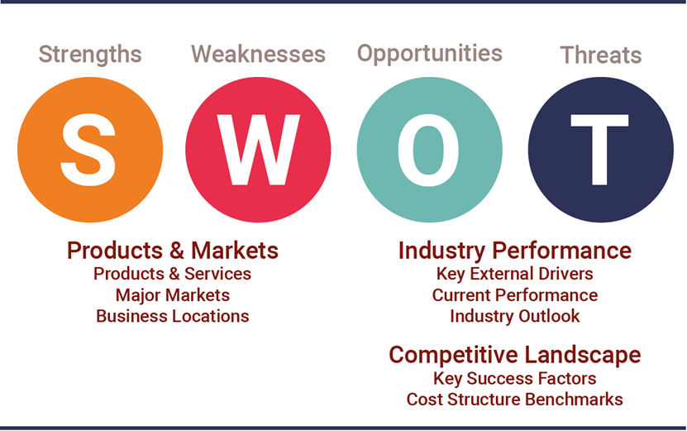

**SOWT ANALYSIS**

**Strength**

* Innovative financial products of diverse categories.
* Kotak Mahindra Finance Ltd. is the first company in the Indian banking history convert to a bank.
* Comprehensive Cash Management System.
* Has over 20,000 employees.
* Customer account base of over 2.7 million.

**Weaknesses**

* Lesser penetration as being late entrants.
* Low publicity and marketing as compared to other premium banks in the urban areas.

**Opportunities**

* Increase in Industry banking.
* Explore opportunities abroad by International banking.

**Threats**

* Economic slowdown.
* Highly competitive environment.
* Stringent Banking Norms.

**ACHIEVEMENTS**

* + Uday Kotak: “CEO of the Year Award” at CNBC-Awaaz CEO Awards 2018
  + Uday Kotak: USIBC Global Leadership Award
  + Jaimin Bhatt: CFO India Hall of Fame Honouree 2019 at the 9th Annual CFO100 Programme  by CFO100 India
  + Shanti Ekambaram: Most Powerful Women in Business 2018 by Fortune India
  + Deepak Sharma: ‘NextGen Digital Leader' for the year 2019  at the Dataquest Technology Innovation Summit & Awards
  + 9th Annual CFO100 Programme bestows the CFO100 2019 Roll of Honour on the following individuals:
    - Gobind Jain in the Risk Management category
    - Himanshu Vasa in the Technology Category
    - R Anantha Raman in the Internal Audit and Control Category
  + Bhargesh Ojha Senior Executive Vice President- General Counsel: General Counsel BFSI Category at the General Counsel Summit 2018
  + Pawan Mahajan, VP-Legal: Rising Star Under 40 at the 3rd Annual 40 under 40 Rising Star Awards 2018
  + Euromoney Awards for Excellence 2018: India’s best bank
  + Euromoney Awards for Excellence 2018: Best Bank in the Emerging Markets in the Euromoney Regional Awards
  + AsiaMoney Best Bank Awards 2019, India: Best Domestic Bank
  + The Tata Mumbai Marathon 2019 Philanthropy Awards Nite recognises:
    - Kotak Mahindra Bank as the Highest Fund Raising Corporate
    - KVS Manian, President – Corporate, Institutional and Investment Banking as the TMM Legend
    - Shanti Ekambaram, President - Consumer Banking as the Change Icon
    - Manish Kothari, Senior Executive Vice President & Business Head - Corporate Banking as the Change Champion
  + The Asset Triple A Country Awards 2018:
    - Kotak Mahindra Bank: Best Bank, Domestic – India
    - Kotak Mahindra Bank: Best Acquisition Finance - Torrent Pharmaceuticals 36 billion rupee non-convertible debentures
  + Best Mid-Sized Bank Award: Business Today-Money Today Financial Awards 2018-2019
  + The Asian Banker Financial Technology Innovation Award
    - Best Innovation Centre by Financial Institution in India
  + The Asian Banker - Banker’s Choice Awards:
    - Best Cash Management Bank in India
    - Best Supplier Relationship Management in India: Kotak Mahindra
    - Best E-commerce Initiative, Application or Programme: “Kotak ALLPAY”
    - Shekhar Bhandari as The Transaction Banker of the Year in Asia Pacific 2019
  + Aadhaar Excellence Awards 2018:
    - Kalyan (W), Thane, Maharashtra: Best Performing Branch of Kotak Mahindra Bank in terms of Aadhaar Generation & Update
    - Kotak Mahindra Bank: 3rd Best Performing Private Bank in terms of Total Aadhaar Generation & Update
  + Best Bank for CTS Clearing Operations for year 2017 by NPCI
  + Icon of Indigenous Excellence Award at the 2nd Annual Economic Times Iconic Brand Summit 2018
  + Kotak Silk: Things women are tired of hearing awarded gold under the Best use of branded content for (Gold) by Social Samosa
  + 2018 DMA Asia Echo:
    - Karthi Marshan, Chief Marketing Officer, Kotak Mahindra Group: DMA Knight Award
    - Elizabeth Venkataraman, Executive Vice President – Marketing, Kotak Mahindra Bank: DMA Marketing Influencer Award
  + 2018 DMA Asia Echo:
    - Best integrated campaign : 811 Shop Pay Bank Live (Gold)
    - Best campaign for social good: #Thankyoufauji (Silver)
    - Best integrated campaign: Kona Kona Cashfree (Silver)
    - Best use of email marketing: Saving Inactive base CLCM (Bronze)
  + India Banking Summit and Awards 2018:
    - Technology Innovator of the year for Innovative use of Data Storage devices
    - Customer Service Provider of the Year - Private Bank
  + 'The Sourcing Luminary' Award at the Machine Conference 2018
  + IDC Digital Transformation Awards 2018
    - Omni-experience innovator- Improve Customer experience and automate operations
    - DX Leader- KEYA - AI Led Voice BOT
  + Voice Bot (Keya) selected as one of the Best 50 Innovative Applications in AI at the NASSCOM AI Game Changer Awards 2018
  + Annual Report 2016-17 -“Silver Winner, Worldwide” at the League of American Communications Professionals (LACP) 2017 Vision Awards
  + Annual Report 2017-18 – “Silver Winner, Worldwide” at the League of American Communications Professionals (LACP) 2018 Spotlight Awards Global Communications Competition
  + Kotak Bank’s Annual Report has been adjudged as the recipient of ‘Certificate of Merit’ for the year 2017 in the category ‘Private Sector Banks (including Co-operative Banks SAFA Best Presented Annual Report Awards 2017
  + Interact, the Real time omni-channel recommendation engine for retail bank wins Best Data Science Project award at Cypher 2018
  + IR Magazine Forum and Awards:
    - Kotak IR team: Runner Up, Best Investor Relations Team (Large Cap)
    - Nimesh Kampani, SVP & Head-Investor Relations : Runner Up, Best Investor Relations Officer
  + The Asset Triple A Digital Awards:
    - Most Innovative Emerging Digital Technologies Project - Kotak Mahindra Bank: WhatsApp Business API
  + Financial Express India's Best Bank Awards 2018: Best Savings Bank Product award for 6% interest p.a.
  + Runner Up : IAMAI 9th India Digital Awards
    - Best Digital API – Open Banking - Kotak Mahindra Bank
  + BFSI Digital Innovation Award 2019 under the category “Enterprise Mobility” for successfully executing and supporting the Enterprise Network- LAN
  + Kotak 811 – India Invited Campaign wins “Silver” under the Integrated Campaign category at MADDYS 2019 held by the Madras Advertising Club
  + Kotak 811 recognised under the Enterprise Mobility Category by NetApp Innovation Awards 2018



**FUTURE PLANS**

Kotak Mahindra Bank slipped into negative territory after the foreign investment promotion board deferred the lender’s plea to raise the foreign holding limit in the bank to 55% from 49% currently. The proposed rise has implications on Kotak’s insurance business.

Kotak Mahindra fell 0.7% to Rs.1,426 after rising to Rs.1,461 in early deals. Its application for raising the overseas holding limit has failed to pass muster twice in this year. The FII stake in Kotak Bank is already at 48.6% after it bought out smaller rival ING Vysya Bank earlier this year.

India currently caps foreign in Insurance companies at 49%. Parent Kotak Bank runs an insurance venture Kotak Mahindra old Mutual Insurance, in which it controls a 74% share. If the foreign ownership of Kotak Bank were exceed 51% then the bank will be in violation of rules governing sectoral caps in the insurance space.

**FUNCTIONAL PROFILE**

**FINANCIAL PRODUCTS AND SERVICES**

Financial Products and Services of Kotak Mahindra Bank are

**SAVINGS ACCOUNT**

Open an 811 Digital savings Bank account in an instant, without ever stepping out of your home.811 being a zero balance savings account, there is no commitment on maintaining a minimum balance. What’s more you will earn up to 6%* interest per annum, transfer funds online for free, get a virtual debit card and much more with this amazing savings account.

**FIXED/ RECURRING DEPOSIT**

The Kotak Recurring Deposit is designed for you to achieve your goals on your own terms. This deposit gives you the freedom to choose a Term & Amount you wish to invest every month and earn Guaranteed Return at applicable interest rate. Make the smart choice and maximize your returns from your savings now.

|  |  |  |
| --- | --- | --- |
| TENURE | INTEREST RATE p.a.(%) | SENIOR CITIZEN RATES p.a.(%) |
| 6 Months | 5.80% | 6.30% |
| 9 Months | 6.05% | 6.55% |
| 12 Months | 6.20% | 6.70% |
| 15 Months | 6.20% | 6.70% |
| 18 Months | 6.20% | 6.70% |
| 21 Months | 6.20% | 6.70% |
| 24 Months | 6.20% | 6.70% |
| 27 Months | 6.20% | 6.70% |
| 30 Months | 6.20% | 6.70% |
| 33 Months | 6.20% | 6.70% |
| 3 Years-> 4Years | 6.10% | 6.60% |
| 4Years->5Years | 6.10% | 6.60% |
| 5Years-10Years | 6.00% | 6.50% |

**CHEQUE BOOK REQUEST**

Kotak Mobile Banking is one of the best way to manage your account on phone. You can request Cheque Book easily through mobile banking.

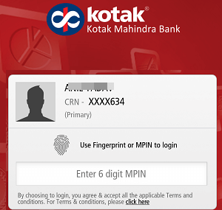 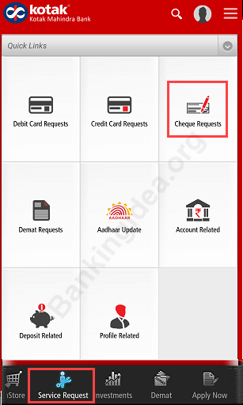

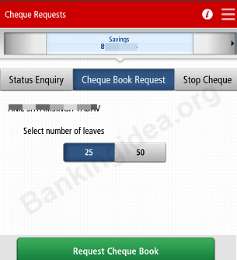

**LOANS**

In finance, a loan is the lending of money by one or more individuals, organizations, or other entities to other individuals, organizations etc. The recipient (i.e., the borrower) incurs a debt and is usually liable to pay interest on that debt until it is repaid as well as to repay the principal amount borrowed.

The document evidencing the debt (e.g., a promissory note) will normally specify, among other things, the principal amount of money borrowed, the interest rate the lender is charging, and the date of repayment. A loan entails the reallocation of the subject asset(s) for a period of time, between the lender and the borrower.

The interest provides an incentive for the lender to engage in the loan. In a legal loan, each of these obligations and restrictions is enforced by contract, which can also place the borrower under additional restrictions known as loan covenants. Although this article focuses on monetary loans, in practice, any material object might be lent.

Acting as a provider of loans is one of the main activities of financial institutions such as banks and credit card companies. For other institutions, issuing of debt contracts such as bonds is a typical source of funding.

**INVESTMENT ACCOUNT**

To invest is to allocate money in the expectation of some benefit in the future.

In finance, the benefit from an investment is called a return. The return may consist of a gain (or loss) realised from the sale of property or an investment, unrealised capital appreciation (or depreciation), or investment income such as dividends, interest, rental income etc., or a combination of capital gain and income. The return may also include currency gains or losses due to changes in the foreign currency exchange rates.

Investors generally expect higher returns from riskier their investments. When a low risk investment is made, the return is also generally low. Similarly, high risk comes with high returns.

Investors, particularly novices, are often advised to adopt a particular investment strategy and diversify their portfolio. Diversification has the statistical effect of reducing overall risk.

**DEBIT CARDS**

A debitcard (also known as a bankcard, plastic card or check card) is a plastic payment card that can be used instead of cash when making purchases. It is similar to a credit card, but unlike a credit card, the money is immediately transferred directly from the cardholder's bank account when performing any transaction.

Some cards might carry a stored value with which a payment is made, while most relay a message to the cardholder's bank to withdraw funds from a payer's designated bank account. In some cases, the primary account number is assigned exclusively for use on the Internet and there is no physical card.

In many countries, such as most of Western Europe, the use of debit cards has become so widespread that their volume has overtaken or entirely replaced cheques and, in some instances, cash transactions. The development of debit cards, unlike credit cards and charge cards, has generally been country specific resulting in a number of different systems around the world, which were often incompatible. Since the mid-2000s, a number of initiatives have allowed debit cards issued in one country to be used in other countries and allowed their use for internet and phone purchases.

Debit cards usually also allow instant withdrawal of cash, acting as an ATM card for this purpose. Merchants may also offer cashback facilities to customers, so that a customer can withdraw cash along with their purchase.

**CREDIT CARDS**

A creditcard is a payment card issued to users (cardholders) to enable the cardholder to pay a merchant for goods and services based on the cardholder's promise to the card issuer to pay them for the amounts plus the other agreed charges. The card issuer (usually a bank) creates a revolving account and grants a line of credit to the cardholder, from which the cardholder can borrow money for payment to a merchant or as a cash advance.

A credit card is different from a charge card, which requires the balance to be repaid in full each month. In contrast, credit cards allow the consumers to build a continuing balance of debt, subject to interest being charged. A credit card also differs from a cash card, which can be used like currency by the owner of the card. A credit card differs from a charge card also in that a credit card typically involves a third-party entity that pays the seller and is reimbursed by the buyer, whereas a charge card simply defers payment by the buyer until a later date.

**FIXED DEPOSIT**

If you want to boost your savings with an absolute peace of mind, a fixed deposit investment is the perfect fit for you. The promise of assured savings after a fixed tenure makes fixed deposits an attractive investment avenue for planning your medium and long-term goals.

|  |  |  |
| --- | --- | --- |
| TENURE | INTERST RATES FOR REGULAR DEPOSIT | INTERST RATES FOR SENIOR CITIZEN |
| 7 to 14 Days | 3.50% | 4.00% |
| 15 to 30 Days | 4.00% | 4.50% |
| 31 to 45 Days | 4.75% | 5.25% |
| 46 to 90 Days | 5.25% | 5.75% |
| 91 to 120 Days | 5.40% | 5.90% |
| 121 to 179 Days | 5.40% | 5.90% |
| 180 Days | 5.75% | 6.25% |
| 181 to 269 Days | 5.80% | 6.30% |
| 270 Days | 5.80% | 6.30% |
| 271 to 363 Days | 6.05% | 6.55% |
| 364 Days | 6.05% | 6.55% |
| 365 to 389 Days | 6.30% | 6.80% |
| 390 Days | 6.30% | 6.80% |
| 391 to 22 Months 29 Days | 6.30% | 6.80% |
| 23 Months | 6.30% | 6.80% |
| 23 Months 1day to 1year 11 Months 29 Days | 6.30% | 6.80% |

**HEALTH INSURANCE**

Everyone is looking to make quality health care accessible to their family. With ever-rising medical costs, it becomes quite challenging. Buying a right health plan helps you get an adequate health coverage without any financial worries. Kotak General Insurance Company offers health plan to suit you & your family’s healthcare needs.

|  |  |  |  |  |  |
| --- | --- | --- | --- | --- | --- |
| PLAN | TYPE | MIN/ MAX AGE | MIN/ MAX SI | AVAILABILITY | TENURE |
| Kotak Health Care- Excel | Individual/Family Floater | Adult: 18 years– 65 years Child: 91 days – 25 years | Min SI: 2 Lakh Max SI: 4 Lakh | Online | Min: 1 year Max: 3 years |
| Kotak Health Care- Premium | Individual/Family Floater | Adult: 18 years– 65 years Child: 91 days – 25 years | Min SI: 5 Lakh Max SI: 25 Lakh | Online | Min: 1 year Max: 3 years |
| Kotak Health Care- Prime | Individual/Family Floater | Adult: 18 years– 65 years Child: 91 days – 25 years | Min SI: 10 Lakh Max SI: 100 Lakh | Online | Min: 1 year Max: 3 years |

**BANK + DEMAT + TARDING ACCOUNT**

The Trinity – Bank + DP+ Trading A/c accounts helps you enjoy the benefits of a Bank Account, Demat Account & Trading Account for seamless banking & trading experience.

The Trinity – Bank + DP+ Trading A/c account includes: Kotak Bank Savings Account + Kotak Securities Demat Account + Kotak Securities Trading Account.

**PERSONAL LOAN**

Need a personal loan to meet your immediate financial requirements? Make sure you run through the basic personal loan eligibility criteria listed below to avail a personal loan as fast as possible, only from Kotak Mahindra Bank. Also, remember to put in place all the necessary documents well ahead in time, for faster processing of your personal loan.

|  |  |
| --- | --- |
| LOAN | PERSONAL LOAN |
| Fixed Interest Rate | Starting 10.99% |
| Loan Processing Charges | Upto 2.5% of the loan amount+ GST and other applicable statutory levies |
| Stamping Charges | Applicable as per the respective State's Stamp Act |
| Credit Administration Charges | Upto 5% of the Loan amount, not exceeding Rs. 7500 (inclusive of GST ) |
| Credit Appraisal Charges | Upto 5% of the Loan amount, not exceeding Rs. 7500 (inclusive of GST ) |
| Overdue Interest | 3% p.m compounded monthly on the Amount due but unpaid from the Date of the Amount falling Due till the Date of actual payment |
| Collection Charges | 30% (inclusive of GST and other applicable statutory levies)of cheque / instrument dishonour charges+ overdue interest |
| Dishonour Charges Per Instance | Rs. 750 per instance (inclusive of GST and other applicable statutory levies) |
| Swap Charges (Change in mode of repayment/Instrument/EMI Date swap) | Rs.500 per Swap per Instance+ GST and other applicable statutory levies |
| Prepayment Interest / Forclosure Charges | Lock in period for 12^ months. After 12 months, 5% foreclosure charges + GST on principal outstanding. |
| Duplicate Issue of NOC | Nil |
| No Due Certificate | Nil |
| Charges for furnishing a copy of the credit information report (CIBIL) to the applicant. | Rs. 50 + GST and other applicable statutory levies per instance |
| Charges applicable in case customer requests for copies of records pertaining to his transactions ( SOA / Amortization Schedule) | Once yearly without any charge. Post that Rs.200 per request+ GST and other applicable statutory levies |

**CAR LOAN**

In today’s world, owning a car has almost become a necessity with the freedom of movement and comfort that it offers. And with the Kotak Mahindra Prime Ltd. Car Loan, your dream of owning a car can become a reality with minimum effort.

We provide new as well as used car loans, all tailored to meet your individual requirement with flexible schemes. Additionally, our convenient repayment options, easy processing, and flexible car loan interest rates mean that, no matter what your dream car, we can help you turn that dream into a reality.

|  |  |  |
| --- | --- | --- |
| **Features and Eligibility** | **Kotak Bank New Car Loan Scheme** | **Kotak Bank Used Car Loan Scheme** |
| Rate of Interest | 11.50% Fixed | Not Available |
| Loan Amount Eligibility | 90% of ex-showroom price | Not Available |
| Lowest EMI per Lakh | Rs. 2,199 | Not Available |
| Maximum Repayment Tenure | 5 years | Not Available |
| Age (years) | Between 21 years and 65 years |  |
| Foreclosure Charges | Not allowed for 6 months; 5.21% charges after 6 months | Not Available |

**HOME LOANS**

We understand how special it feels to place the first step into your own new home. It’s exactly why Kotak Mahindra Bank provides you a bouquet of customised home loan plans to choose from, for a seamless and pleasurable home-buying experience.

|  |  |  |  |  |  |
| --- | --- | --- | --- | --- | --- |
| Category of beneficiaries | Maximum Household Income | Interest Subsidy (p.a.) | Maximum Subsidy Amount | Maximum eligible loan amount for subsidy | Eligible carpet area |
| EWS Economically Weaker Section (EWS) | Up to Rs.6 lakh | 6.5% | Rs.2.67 lakh | Rs.6 lakh | No restriction For home extension/repair - 30 sqm |
| LIG Low Income Group (LIG) | Above Rs.3 lakh and up to Rs.6 lakh | 6.5% | Rs.2.67 lakh | Rs.6 lakh | No restriction For home extension/repair - 60 sqm |
| Middle Income Group (MIG –I) | More than Rs.6 lakh and up to Rs.12 lakh | 4% | Rs.2.35 lakh | Rs.9 lakh | 160 sqm |
| Middle Income Groups (MIG- II) | More than Rs.12 lakh and up to Rs.18 lakh | 3% | Rs.2.30 lakh | Rs.12 lakh | 200 sqm |

**BALANCE SHEET OF KOTAK MAHINDRA BANK**

| **Particulars** | **Mar 2019 ( ).Cr** | **Mar 2018 ( ).Cr** | **Mar 2017 ( ).Cr** | **Mar 2016 ( ).Cr** | **Mar 2015 ( ).Cr** | **Mar 2014 ( ).Cr** |
| --- | --- | --- | --- | --- | --- | --- |
| **SOURCES OF FUNDS :** |  |  |  |  |  |  |
| Capital | 1454.38 | 952.82 | 920.45 | 917.19 | 386.18 | 385.16 |
| Reserves Total | 41444.00 | 36528.83 | 26695.62 | 23041.87 | 13754.91 | 11889.93 |
| Equity Share Warrants | 0.00 | 0.00 | 0.00 | 0.00 | 0.00 | 0.00 |
| Equity Application Money | 2.07 | 2.17 | 1.87 | 3.41 | 3.00 | 8.53 |
| Deposits | 225880.36 | 192643.27 | 157425.86 | 138643.02 | 75759.56 | 59959.95 |
| Borrowings | 32248.29 | 25154.15 | 21095.48 | 20975.34 | 11250.46 | 12007.96 |
| Other Liabilities & Provisions | 11303.57 | 9795.43 | 8596.62 | 8804.93 | 4921.95 | 3333.82 |
| **TOTAL LIABILITIES** | 312332.67 | 265076.67 | 214735.90 | 192385.76 | 106076.06 | 87585.35 |
| **APPLICATION OF FUNDS :** |  |  |  |  |  |  |
| Cash & Balances with RBI | 10877.53 | 8908.50 | 7492.42 | 6903.43 | 3928.30 | 2948.23 |
| Balances with Banks & money at Call | 13798.02 | 10711.60 | 15079.58 | 3976.28 | 2334.06 | 3031.66 |
| Investments | 71189.09 | 64562.35 | 45074.19 | 51260.22 | 28659.11 | 25484.55 |
| Advances | 205694.81 | 169717.92 | 136082.13 | 118665.30 | 66160.71 | 53027.63 |
| Fixed Assets | 1651.55 | 1527.16 | 1537.63 | 1551.59 | 1206.71 | 1106.94 |
| Other Assets | 9121.70 | 9649.14 | 9469.94 | 10028.94 | 3787.17 | 1986.33 |
| Miscellaneous Expenditure not written off | 0.00 | 0.00 | 0.00 | 0.00 | 0.00 | 0.00 |
| **TOTAL ASSETS** | 312332.70 | 265076.67 | 214735.89 | 192385.76 | 106076.06 | 87585.34 |
| Contingent Liability | 211945.94 | 204936.05 | 192958.64 | 242522.28 | 63602.29 | 43813.59 |
| Bills for collection | 31852.23 | 24255.31 | 20318.26 | 14964.05 | 4419.99 | 3015.60 |

**SOURCES OF FINANCE**

# Kotak Mahindra Bank Ltd.

|  |  |  |  |  |  |
| --- | --- | --- | --- | --- | --- |
| **Cash Flow** | | | | | |
| Rs (in Crores) | | | | | |
| **Particulars** | **Mar'19** | **Mar'18** | **Mar'17** | **Mar'16** | **Mar'15** |
| Profit Before Tax | 4865.33 | 4084.30 | 3411.50 | 2089.78 | 1865.98 |
| **Net Cash Flow from Operating Activity** | **-3387.72** | **-10274.92** | **14411.92** | **6133.72** | **5121.93** |
| **Net Cash Used in Investing Activity** | **798.11** | **-2515.50** | **-2971.84** | **-6363.01** | **-4112.53** |
| **Net Cash Used in Financing Activity** | **7633.07** | **9837.22** | **256.52** | **-1463.91** | **-726.93** |
| **Net Inc/Dec In Cash and Cash Equivalent** | **5055.43** | **-2951.90** | **11692.29** | **-1693.19** | **282.47** |
| Cash and Cash Equivalent - Beginning of the Year | 19620.11 | 22572.01 | 10879.72 | 12572.91 | 5979.89 |
| Cash and Cash Equivalent - End of the Year | 24675.54 | 19620.11 | 22572.01 | 10879.72 | 6262.36 |

Rs (in Crores)

**RECRUITMENT PROCESS**

**Name of the Post:**

● Relationship Manager

● HO Acquisition Manager – Digital Sales

● Asst Acquisition Manager – CASA

● Customer Service Executive

● Sales Executive

● Service Officer

● Assistant Manager

● Branch Manager

● General Manager

● Manager

● Marketing Manager

● Credit Manager

● Officer

● Prohibitory officer

● Program Manager

**Qualification**:

Candidate for Kotak Mahindra Bank Recruitment 2018 should have completed Any Graduate/Post Graduate in any discipline to entry level for Freshers for Kotak Mahindra Bank Recruitment Process 2018.

**Note**:

Documents required for Kotak Mahindra Bank Recruitment Process 2018 (Original & photocopies) of SSC Marksheet, HSC/Diploma Marksheet, Graduation & Post Graduation all years’ mark sheets, Photo ID proof (Pan Card/ Passport/ Driving License/ College ID), 2 photographs & Resume for Kotak Mahindra Bank recruitment for freshers.

**Selection Procedure**:

Online Test / Technical interview / HR interview

**How to Apply**:

Eligible & Interested candidates can download the application in Official website page in www.kotak.com Kotak Mahindra Bank Recruitment 2018.

**Instructions to Apply**:

Log on to the Official website of Kotak Mahindra Bank www.kotakcareer.in. Then, Click on the careers link. Select the link available for the opening. Fill the Application with required details. Pay the Application Fee to complete the Registration Process

**Important Link:**

**Online Application:**[**Click Here to Apply**](javascript:void(0);)

**INCENTIVES**

**BONUS**

Kotak Mahindra Bank pays an average of ₹94,531 in annual employee bonuses. Bonus pay at Kotak Mahindra Bank ranges from ₹59,496 to ₹101,130 annually among employees who report receiving a bonus. Employees with the title Credit Manager earn the highest bonuses with an average annual bonus of ₹101,130. Employees with the title Operations Manager earn the lowest bonuses with an average annual bonus of ₹59,496.

**BENEFITS FOR CORPORATIVES**

* Customized salary account proposition for all employees
* Web based salary upload process
* **Corporate Credit Cards** - Discover privileges and benefits every time you swipe*.
* Single point of contact (Corporate Relationship Manager) across the country∙
* **Kotak Paymint Card for employees** - Manage multiple reimbursements and allowances such as meal vouchers, medical reimbursements, leave travel allowances, gift cards, conveyance, fuel allowances etc.
* National Pension System at special rates∙
* Company Car Lease Program through Kotak Mahindra Prime Ltd
* Captive ATM @ Corporate premises if the employee count is > 1200 employees at a single site
* Kotak World Travel Cards at special rates available in 13 currencies
* **Kotak Current Account** – Differentiated account to best suit your business needs and help you reach your business goals sooner
* **Kotak Corporate Banking** – A comprehensive product suite to cater to your Corporate Banking requirements$
  + **Finance** – Working capital, Long term loans & Structured finance
  + **Transaction Banking** – Trade finance, Supply chain solutions, Remittances, Cash management and Escrow services
  + **Investments** – Term deposits, Mutual funds# and Structured instruments
  + **Treasury** – Debt capital markets, Forex and Derivatives
* **Value Added Services\*\*** to cater to corporate requirements in terms of Media Solutions, Cloud-Business Apps, Tax Solutions, Workplace Solution, Digital Signature & Certificates, Digital Media, Travel Services and Concierge Services

**BENEFITS FOR EMPLOYEE**

* #PayShopMore Debit Card with Rs.40,000 /Rs.50,000 cash withdrawal limit at Domestic / International ATMs per day and Rs.2,00,000 shopping limit per day
* Personal Accidental Death Cover of up to INR 2 lakhs. [Click here](https://www.kotak.com/en/personal-banking/cards/debit-card-services/insurnace-on-debit-card.html) for Terms and Conditions
* Maximum of 5 transactions free in a month with a cap of maximum 3 free transactions at non-Kotak ATMs in Top 6#+ cities in India 2
* Lost Card Liability Insurance of up to Rs.2,00,000
* Purchase Protection of up to Rs. 50,000
* Instant Personal Loan offered 5
* Home Loans at preferential rates with zero processing fee 5
* Up to 100% Car finance with preferential rates offered by Kotak Mahindra Prime Limited, a Kotak Group Company 6
* PVR Kotak Credit Card offers two PVR tickets free on spends of Rs. 10,000 per month
* Choose from a suite of Credit Cards to match your lifestyle 7
* Get a Free Investment Account and redeem or purchase from over 2,200 Mutual Funds online
* Trinity Account which is a 3-in1 combination of a Savings account, Demat account and Trading account 8
* Preferred brokerage rates on trinity account from Kotak Securities on delivery buy or sell
* Book Fixed Deposits and Recurring Deposits online at attractive interest rates
* Free Payable at par cheque book upto 25 leaf per quarter
* Transfer funds anytime 24X7 using IMPS, even on a bank holiday
* Net Banking and Mobile Banking for convenient online banking
* SMS banking through Kotak Bharat Banking App
* Customer care officers available 24 X 7, and IVRS option for self-service
* Instacheck, a toll free number for instant SMS alert on account balance and last 3 credit transactions
* Utility bill payment services through Auto Pay
* Netc@rd, a single use virtual card to ensure secure online transactions
* Dedicated service helpdesk id
* Visa money transfer
* Payment Gateway
* Kotak Multi Currency World Travel Card for travelling abroad without worry
* Best Compliments Card, a pre-paid card for gifting
* Employee reimbursement account

## **MARKETING MIX 4P’S**

## **Product**

**The product strategy and mix in Kotak Mahindra Bank marketing strategy can be explained as follows**:

Kotak Mahindra Bank is one of the leading banks in India. Kotak Mahindra Bank has the following business verticals as a part of its marketing mix: Consumer Banking, Commercial Banking, Corporate Banking and Wealth Management. It has unique programs cut to match different needs of its customers like Silk, which is a savings programme for women; Edge Saving Account; Jifi accounts; Kotak 3-in-1 account; Junior account to promote savings among minors starting at a young age.

**Wide range of Kotak Mahindra loans offered**:

* Personal Loans
* Home Loans
* Tractor Finance
* Crop Loans
* Rural Auto & Farm Equipment Finance
* Home Improvement Loans
* Home Loan Balance Transfer
* Gold Loans
* Loan Against Securities
* Infrastructure Finance
* Unnati Auto Finance

## **Price**

**Below is the pricing strategy in Kotak Mahindra Bank marketing strategy**:

Kotak Mahindra Bank faces tough competition from the likes of HDFC Bank, ICICI Bank, IndusInd Bank, Axis Bank, etc. The private sector bank industry has cut throat competition in proving the best customer experience, suitable interest rates and convenience. Kotak Mahindra Bank follows a competitive strategy in pricing to maintain and acquire more customers. It provides an interest rate of 6.90% on fixed deposits, which is at par with its competitors.

## **Place**

**Following is the distribution strategy of Kotak Mahindra Bank**:

Kotak Mahindra bank is present in 675 areas with 2000+ ATMS. It has 1300+ branches across the country. The reach of Kotak Mahindra Bank is less that of its competitors like HDFC bank, which it the market leader. Public sector banks like Punjab National Bank are more widely available. Kotak Mahindra is third largest by market capitalization but it must also increase its physical presence across the country and globe.

Kotak Mahindra Bank is also accessible on smartphone with its recently launches mobile phone app called Kotak Bharat Banking App.

## **Promotion**

**The promotional and advertising strategy in the Kotak Mahindra Bank marketing strategy is as follows**:

Kotak Mahindra Bank turned twenty-five years old in 2011, on the occasion of which it launched a ‘youthful at 25 years’ campaign. It launched a ten-second high impact television commercial and print advertisements. The campaign talked about how money can build self-esteem and provide security. Kotak Mahindra Bank also created a character called Subbu who is the voice of the brand who talks about different products offered by the bank across platforms like television, print and digital. Kotak Mahindra Bank is also knowing to advertise through hoardings.

**CHAPTER 3**

**CONCEPTUAL PROFILE**

**THEORETICAL ASPECTS OF THE CONCEPT**

**E-payment System**

E Banking is your personal banking service on the Internet, protected with bank identifiers. It is available anywhere, anytime. E-Banking allows you to pay invoices to finish and foreign recipients easily and securely. You can also check your account balances and transactions. You can order a new card, withdraw a loan granted to you and make mutual fund subscriptions.

E-Payment system is a way of making transactions or paying for goods and services without exchanging Physical cash i.e. payments are made by using advanced technology called electronic medium.

An e-commerce payment system facilitates the acceptance of electronic payment for online transactions. Also known as a sample of Electronic Data Interchange (EDI), e-commerce payment systems have become increasingly popular due to the widespread use of the internet-based shopping and banking.

Online payment systems remain a major factor in today’s ecommerce sector. Because businesses are expanding globally and also offering online options, the need for alternative forms of payment are quite significant. The use of online payment systems began in the 1960’s and was used mainly among financial and banking institutions. It was during this time that ATM’s and credit cards were first introduced to consumers. Since then, the use of online payment systems has increased substantially and has changed the way consumers do business. Online payment systems have also served as a catalyst for new business formations and social practice.

Electronic payment systems began with Electronic Fund Transfer (ETF). An electronic fund transfer is defined as a financial application of Electronic Data Interchange (EDI), which sends credit card numbers or electronic checks via secured private networks between banks.

The term, electronic money, was formed from online payment systems. It is defined as money or scrip which is only exchanged electronically. Online payment systems allow individuals to participate in money exchanges through computer networks such as the internet.

An e-payment system is a way of making transactions or paying for goods and services through an electronic medium, without the use of checks or cash. It’s also called an electronic payment system or online payment system. Read on to learn more.

The electronic payment system has grown increasingly over the last decades due to the growing spread of internet-based banking and shopping. As the world advances more with technology development, we can see the rise of electronic payment systems and payment processing devices. As this increase, improve, and provide ever more secure online payment transactions the percentage of check and cash transactions will decrease.

**Electronic Payment Methods**

One of the most popular payment forms online are credit and debit cards. Besides them, there are also alternative payment methods, such as bank transfers, electronic wallets, smart cards or bitcoin wallet (bitcoin is the most popular cryptocurrency).

E-payment methods could be classified into two areas, credit payment systems and cash payment systems.

**Credit Payment System**

CreditCard — A form of the e-payment system which requires the use of the card issued by a financial institute to the cardholder for making payments online or through an electronic device, without the use of cash.

Still, one of the most popular e-payment methods are credit and debit card #payments

**CLICK TO TWEET**

E-wallet — A form of prepaid account that stores user’s financial data, like debit and credit card information to make an online transaction easier.

Smartcard — A plastic card with a microprocessor that can be loaded with funds to make transactions; also known as a chip card.

**Cash Payment System**

Direct debit — A financial transaction in which the account holder instructs the bank to collect a specific amount of money from his account electronically to pay for goods or services.

E-check — A digital version of an old paper check. It’s an electronic transfer of money from a bank account, usually checking account, without the use of the paper check.

E-cash- It is a form of an electronic payment system, where a certain amount of money is stored on a client’s device and made accessible for online transactions.

Stored-value card — A card with a certain amount of money that can be used to perform the transaction in the issuer store. A typical example of stored-value cards are gift cards.

**Types of EPS**

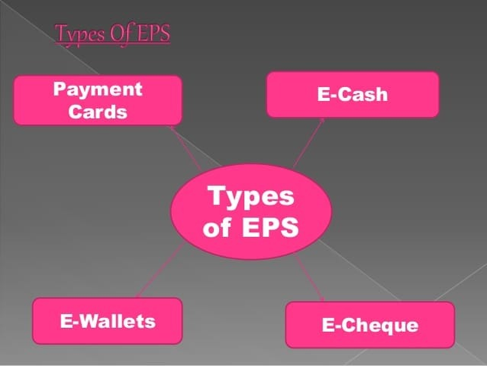

In real world we have two distinct types of payment systems:

1. **Internet –Based payment system**

There are four models of Internet-Based payment system:

1. Payment cards

2. E-cash

3. E-wallets

4. E-cheque

1. **Electronic Transaction-Based payment system**.

1. Secure Electronic Transaction

2. Cyber Cash

3. Net Bill

4. First Virtual Holdings

This is the most common form and allows smooth transactions for all parties.

For the purpose of better understanding about the issues in electronic payments. I have selected this topic.

**Internet –Based payment system**

**Payment Cards**

**CREDIT CARD**

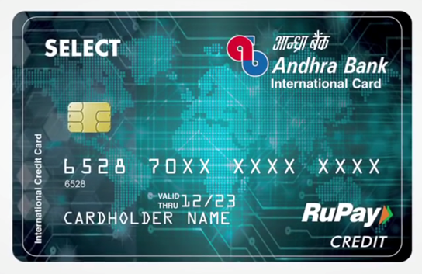

A credit card is a plastic card issued to the users to lent money for purchase of goods and services. The customer types the card number, expiry date and billing address on the order form and the vendor can verify the details and be confident of payment. The credit card payment on the online network can be categorized into three types:

(a) Payment using plain credit card details

(b) Payment using encrypted credit card details

(c) Payment using third party verification.

**DEBIT CARD**

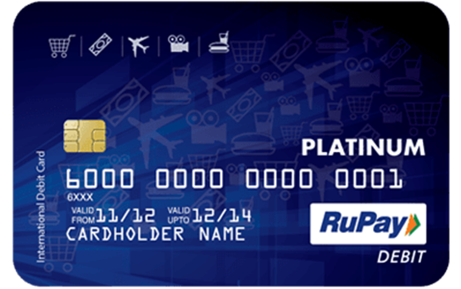

A Debit card is a banking card enhanced with Automated Teller Machine and point of sale features so that it can be used at merchant locations. A Debit card is linked to an individual’s bank account, allowing funds to be withdrawn at ATM and point of sale without writing a cheque. A Debit card holder pay directly through bank for his purchases. It replaces physical cash and cheque. In debit card system customers deposit in advance into the bank and withdraw at the time of purchase. There are two types of debit card which are used in real world:

(a) Online debit card

(b) Offline debit card

**SMARTCARD**

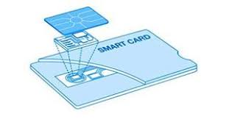

A smart card was first produced in 1977 by Motorola. It is a thin, credit card sized piece of plastic which contains a half-inch-square area that serves as the card’s input-output system. A smart card contains a programmable chip, a combination of RAM and ROM storage and can be refilled by connecting to the bank. It is known as smart card because the ability of chip to store the information in its memory makes the card smart.

Secure Electronic Transaction (SET)- Secure electronic transaction is a system of online payments for ensuring the security of financial transactions on the internet. The SET specification is an open, technical standard for commerce, developed by VISA and master card. It facilitates secure payment card transactions over the internet. Digital certificate creates a trust change throughout the transactions, verifying cardholders and merchant validity.

**E-CASH**

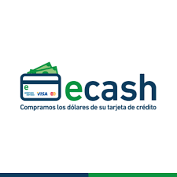

E-Cash is purely software based, anonymous, untraceable, online token payment system, available on Unix, Windows as well as Macintosh platform. When the tokens purchased by customers, the e-Cash software stores the digital money on the customer’s personal computer which is under signed by the bank. The users can easily spend digital money at any shop accepting e-Cash without giving credit card details to the shopkeeper.

**E-WALLETS**

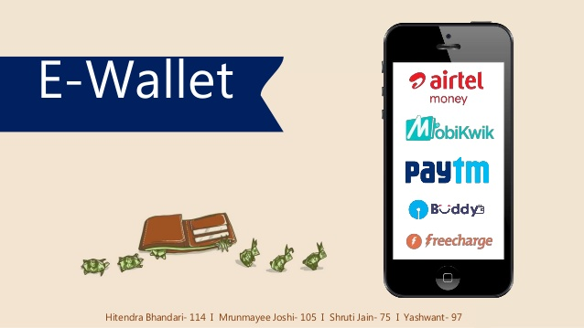

A digital wallet also known as "e-Wallet" refers to an electronic device or online service that allows an individual to make electronic transactions. This can include purchasing items on-line with a computer or using a smartphone to purchase something at a store.Phone pe, Google pay Paytm, PayPal, etc. are the examples for E-wallets.

**E-cheque**

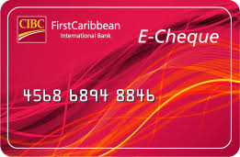

An e- Cheque is an electronic document which substitutes the paper check for online transactions. Digital signatures (based on public key cryptography) replace handwritten signatures.

**Electronic Transaction-Based payment system**

**CYBER CASH**



Cyber cash is a web-based service that automatically processes and verifies customer’s credit card information then debiting the customer’s account and crediting the merchant’s account electronically. Cyber cash servers act as a gateway between the merchant on the internet and bank’s secure financial network. For the purpose of security in electronic payments system this system uses the digital signatures.

**NET BILL**

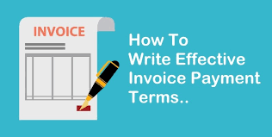

Net bill is a micro payment system. Net bill payment system uses internet for purchasing goods and services and makes secure and economical payments for them. The net bill server maintains account for both consumers and merchants, which allows customers to pay merchants for goods to be delivered. The goods are delivered in digital form. There is a money tool software which verifies receipts of goods. So, net bill system of electronic payment enables the communication between money tool, the merchant server and net bill server.

**FIRST VIRTUAL HOLDINGS**

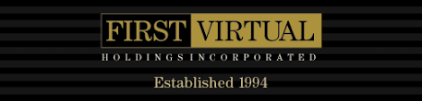

First virtual is one of the first internet payment system that offered a third-party verification method to make payment over the internet. The first virtual payment system is unique in the sense that it does not use encryption. A fundamental philosophy of the payment-system is that certain information should not travel over the internet because it is open network. This information is basically, related with credit card information. Instead of using credit card numbers, the transactions are complete by using a first virtual PIN, which is issued by first virtual company. These PIN numbers can be sent over the internet because it works like Id and no merchant can charged the user’s account without receiving a confirmation e-mail from him.

**APPLICATION OF THE CONCEPT IN THE COMPANY**

**E-BANKING**

It is an E-banking. The provision of banking service through electronic channels and the customers can access the data without time and geographical location.

“Internet banking or E- banking means any user with a personal computer and a browser can get connected to his banks website to perform any virtual banking functions.

In internet banking system the bank has a centralized database that is web-enabled.”

**E-BANKING FACILITIES & PRODUCTS**

Internet banks offer a variety of features and perks, rushing to lure online customer. The race is on to increase market share and creates customer loyality with features that make online banking friendlier, more useful and less expensive.

E-banking hires customers with ‘convenience’.

**The three board facilities that E-banking offers are**

**Convenience**

Complete your banking at your convenience, in the comfort of your home or at any place you can access the net.

**No more queues**

There are no queues at an online bank.

**24/7 service**

Bank online 24 hours a day, 7 days a week and 52 weeks a year.

**ONLINE APPLICATIONS**

Consumers can begin their banking relationship with an online application. No need to waste time driving to a local branch to a begin a banking relationship. Consumers can fill out and submit electronically is submitted, the bank will mail you a signature card for its records and request you to mail or wire your initial funds. Firms like American express enables consumers applying for an account to fund their new account electronically via credit card or cheque from another banking institution. There are some firms such as winspan and usbancshares.com that enables customers to digitally sign their applications.

**ACCOUNT ACCESS**

Internet banking customers now have the ability to view their accounts online, including checking, savings, loans and credit cards. No need to wait for your monthly statements or wait in queue for next available customer representative. Account access enables customers to view most recent activity on accounts, including cleared checks, deposits, ATM transactions and balances as of previous day’s activities. Customers no longer have hold on to the cleared checks, since their bank will store them for them online.

**ACCOUNT TRANSFERS**

Internet banking customers have the ability to transfer funds and their accounts online. With a simple form, customers can move money from a checking account to a savings account and vice versa within safety and convenience of their home without having to visit the ATM funds transferred online are updated in less than 3 hours. In addition, customers can set up recurring transfers of accounts. A recurring transfer will take place on the customer specified date, with a specified amount.

**BACKGROUND PROCESS OF ELECTRONIC PAYMENT SYSTEM IN KOTAK MAHINDRA BANK**

**Conventional vs. Electronic Payment System**

To get into the depth of electronic payment process, it is better to understand the

processing of conventional or traditional payment system. A conventional process of

payment and settlement involves a buyer-to-seller transfer of cash or payment

information (i.e., cheque and credit cards). The actual settlement of payment takes place

in the financial processing network.

A cash payment requires a buyer’s withdrawals form his/her bank account, a transfer of cash to the seller, and the seller’s deposit of payment to his/her account. Non-cash payment mechanisms are settled by adjusting i.e. crediting and debiting the appropriate accounts between banks based on payment information conveyed via cheque or credit cards.

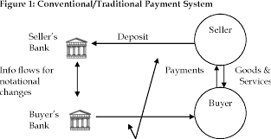

**Process of Electronic Payment System**

Electronic payment systems have been in operations since 1960s and have been

expanding rapidly as well as growing in complexity. After the development of

conventional payment system, EFT (Electronic Fund Transfer) based payment system

came into existence. It was first electronic based payment system, which does not

depend on a central processing intermediary.

An electronic fund transfer is a financial application of EDI (Electronic Data Interchange), which sends credit card numbers or electronic cheques via secured private networks between banks and major corporations.

To use EFT to clear payments and settle accounts, an online payment service will need to

add capabilities to process orders, accounts and receipts. But a landmark came in this

direction with the development of digital currency. The nature of digital currency or electronic money mirrors that of paper money as a means of payment. As such, digital

currency payment systems have the same advantages as paper currency payment, namely

anonymity and convenience.

As in other electronic payment systems (i.e. EFT based and intermediary based) here too security during the transaction and storage is a concern, although from the different perspective, for digital currency systems double spending, counterfeiting, and storage become critical issues whereas eavesdropping and the issue of liability (when charges are made without authorizations) is important for the notational funds transfer.

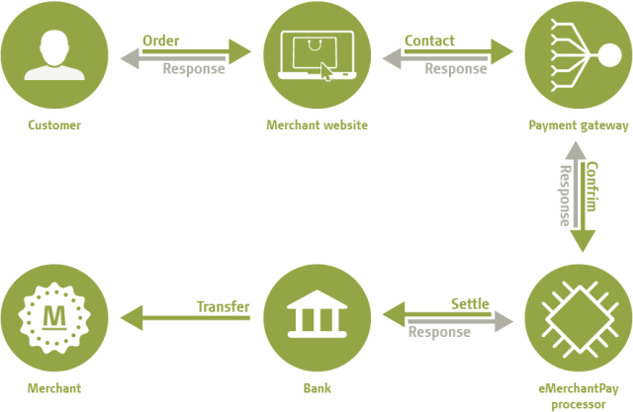

**Types of Electronic Payment Systems**

With the growing complexities in the e-commerce transactions, different

electronic payment systems have appeared in the last few years. At least dozens of

electronic payment systems proposed or already in practice are found. The grouping can

be made on the basis of what information is being transferred online.

**Murthy (2002)explained six types of electronic payment systems**:

(1) PC-Banking

(2) Credit Cards

(3) Electronic Cheques (i-cheques)

(4) Micro payment

(5) Smart Cards and

(6) E-Cash.

**Kalakota and Whinston (1996) identified three types of electronic payment systems**:

(1)Digital Token based electronic payment systems

(2) Smart Card based electronic payment system

(3) Credit based electronic payment systems.

**Dennis (2001) classified electronic payment system into two categories**:

(1) Electronic Cash

(2) Electronic Debit-Credit Card Systems.

**Thus, electronic payment system can be broadly divided into four general types**:

* Online Credit Card Payment
* Electronic Cheque System
* Electronic Cash System
* Smart Card based Electronic Payment System

**Online Credit Card Payment System**

It seeks to extend the functionality of existingcredit cards for use as online shopping payment tools. This payment system has beenwidely accepted by consumers and merchants throughout the world, and by far the mostpopular methods of payments especially in the retail markets. This form of paymentsystem has several advantages, which were never available through the traditional modesof payment. Some of the most important are: privacy, integrity, compatibility, goodtransaction efficiency, acceptability, convenience, mobility, low financial risk andanonymity. Added to all these, to avoid the complexity associated with the digital cash orelectronic-cheques, consumers and vendors are also looking at credit card payments onthe internet as one of possible time-tested alternative.

But, this payment system has raisedseveral problems before the consumers and merchants. Online credit card payment seeksto address several limitations of online credit card payments for merchant including lackof authentication, repudiation of charges and credit card frauds. It also seeks to addressconsumer fears about using credit card such as having to reveal credit information at multiple sites and repeatedly having to communicate sensitive information over the Internet.

Basic process of Online Credit Card Payment System is very simple. If consumers

want to purchase a product or service, they simply send their credit card details to the

service provider involved and the credit card organization will handle this payment like

any other. This can be understood very easily with the format of Credit Card

Payment Form.

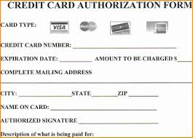

**Electronic Cheque Payment System**

Electronic cheques address the electronic needs of millions of businesses, which today exchange traditional paper cheques with the other vendors, consumers and government. The e-cheque method was deliberately created to work in much the same way as conventional paper cheque. An account holder will issue an electronic document that contains the name of the financial institution, the payer’s account number, the name of payee and amount of cheque. Most of the information is in uncoded form.

Like a paper cheques e-cheques also bear the digital equivalent of signature: a computed number that authenticates the cheque from the owner of the account. Digital chequing payment system seeks to extend the functionality of existing chequing accounts for use as online shopping payment tools.

**Electronic cheque system has many advantages**:

1. They do not require consumers to reveal account information to other individuals

when setting an auction

1. They do not require consumers to continually send sensitive financial information over the web

(3) They are less expensive than credit cards

(4) They are much faster than paper based traditional cheque.

But,this system of payment also has several disadvantages. The disadvantage of electronic cheque system includes their relatively high fixed costs, their limited use only in virtual world and the fact that they can protect the users’ anonymity. Therefore, it is not very suitable for the retail transactions by consumers, although useful for the government and B2B operations because the latter transactions do not require anonymity, and the amountof transactions is generally large enough to cover fixed processing cost.

**The process of electronic chequing system can be described using the following steps**..

**Step 1**: a purchaser fills a purchase order form, attaches a payment advice

(electronic cheque), signs it with his private key (using his signature hardware), attaches

his public key certificate, encrypts it using his private key and sends it to the vendor.

**Step 2**: the vendor decrypts the information using his private key, checks the

purchaser’s certificates, signature and cheque, attaches his deposit slip, and endorses the

deposit attaching his public key certificates. This is encrypted and sent to his bank.

**Step 3**: the vendor’s bank checks the signatures and certificates and sends the

cheque for clearance. The banks and clearing houses normally have a private secure

data network.

**Step 4**: when the cheque is cleared, the amount is credited to the vendor’s account

and a credit advice is sent to him.

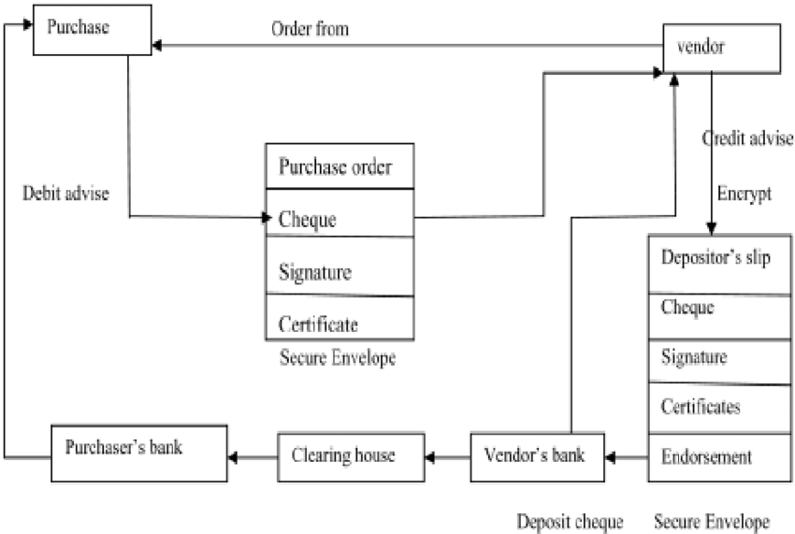

**Electronic Cash Payment System**

Electronic cash (e-cash) is a new concept in online payment system because it combines computerized convenience with security and privacy that improve on paper cash. Its versatility opens up a host of new markets and applications. E-cash is an electronic or digital form of value storage and value exchange that have limited convertibility into other forms of value and require intermediaries to convert.

E-cash presents some characteristics like monetary value, storability and irretrievabiity, interoperability and security All these characteristics make it more attractive payment system over the Internet. Added to these,, this payment system offers numerous advantages like authority, privacy, good acceptability, low transactions cost, convenience and good anonymity. But, this system of payment also has many limitations like poor mobility, poor transaction efficiency and high financial risk, as people are solely responsible for the lost or stolen.

Gary and Perry (2002), just like real world currency counterpart, electronic cash is susceptible to forgery. It is possible, though increasingly difficult, to create and spend forged e-cash.

**E-Cash Structure***:*

E-cash structure could be identified as a string of bits that represents certain values such as reference number and digital signature, which could be used for the security purpose to prevent forgery and criminal use (Wright, 2002).

But, the structure proposed by Wright (2002) needs some extension to make e-cash more secure. Therefore, the present model adds a digital watermark to e-cash structure to protect it from the illegal copy and forgery activities further, the model modified the structure of the reference number to support tractability.

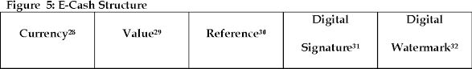

The proposed e-cash structure is comparatively better than suggested by Wright

(2002), because security issue is given importance of top most priority in the present model. But, still there are certain concerns to be addressed for an electronic cash

system.

For example,

Who has the right to issue electronic cash?

Can every bank issue its own money?

If so how do you prevent fraud?

Who will monitor the banking operations to protect consumers?

Many of these concepts relate to the legal and banking regulatory aspects. However all these issues are beyond the scope of the study and therefore, cannot be included here. But, these issues must be addressed before establishing a complete e-cash based payment system.

**CHAPTER 5**

**SUMMARY AND SUGGESTIONS**

**SUMMARY**

The entire research report has been present in the following chapters which are as under.

In chapter number one, Meaning and Definition of the Bank, History and evolution of banking in the world, History of banking in India, Development of banks in India, Banking system in India, Functions of bank, Types of banks, Role of banks in the growth of Indian economy, Present scenario of banking in India, Global challenges in banking sector in India, Innovative services provided by the banks in India and introduction to research problem are included.

In chapter number two, basic concepts related to financial performance, importance of financial performance and how financial performance would be useful to have comparison among different banks.

In third chapter, problem statement, objectives of the study, type of data, review of literature, sampling design, hypothesis and limitations of the study.

In chapter number four, the researcher has discussed about various ratios for the purpose of financial efficiency. Return on Assets, Return on Equity, NIM, CAR, Net NPA Ratio and CDR are main ratios discussed in this chapter. The researcher has applied ANOVA Hypothesis Test to compare the financial performance of selected public sector and private sector banks.

**SUGGESTIONS**

For improving the working of the public sector banks and private sector banks in India following suggestions emerge for consideration.

Appropriate use of technology for improvement in the quality of customer service and ensuring efficiency in operations is crucial for the effective functioning of banks in emerging competitive environment.

Success lies in aligning technology with the business strategy and redefining processes to get maximum advantage.

The attitude of bankers will have to be more customers oriented than procedure oriented. Banks also should provide customer services during extended business hours and also provide ATM facilities covering residential areas to facilitate customers in with drawing cash at any time of the day and night as per their convenience.

Real progress and prosperity depend on harmonious relations among all staff members, customers and all areas of banking. The appointment of CEOs or other top executives should be made by a group of eminent persons functioning efficiently. This would ensure depoliticisation of the process and improved transparency in the accounts of the banks for its shareholders and general public. The process of any reforms in banking system can not gather momentum without evolving reforms in the area of Human Resource Development. Overstaffing, over unionisation and rigid frame work of promotions and transfers, also lack of effective leadership are the principal contributory factors to the disquieting trend in Personal Management.

Thus, the policy should be redefined to making employees committed to the organisation and to the changes that are taking place and to face the future challenges as a cohesive team.

There is a need for increasing competition in the Indian banking system given that the limited entry of small banks allowed so far is unlikely to introduce such competition on an adequate scale. One option is to allow large scale entry of private banks. Allowing the large scale entry of private banks to provide more meaningful competition could help improve the performance of public sector banks, but it has the risk of forcing closure of weak public sector banks. The more viable option would therefore be to privatise at least some of the public sector bank.

Innovation with technology can add to bank’s competitive edge in rendering services to its clients. If it is not possible to be the first in the market, the next best is to become a fast follower i.e. to quickly adapt to the new idea and operationalise it at the earliest. It is necessary to stay ahead, constantly upgrade the products and create new markets. Those who develop innovative methods to reduce cost and provide cheaper and quality service and products at reasonable prices will win. Overall it can be said that the banks also need to improve their product portfolio and must strive to be a one stop shop for the financial needs of middle and upper class income and high net worth individuals. This would be a good step to be a market leader in the highly competitive financial market.

**ANNEXURES**

**Questionnaire on Kotak Mahindra Bank**

1. Which age group do you belong to?
   1. Below 18 yrs b. 18-25 yrs c. 25-40 yrs d. Above 40 yrs
2. How much rate of interest are you paying for personal loans?
   1. 2.5% b. 5% c. 3% d. None of these
3. Are you with the features provided by the app?
   1. Satisfied b. Not satisfied c. partially satisfied
4. How E-payments is useful to you?
   1. High b. Moderate c. Low
5. How frequently do you banking services?
   1. Daily b. Weekly c. Monthly d. Yearly
6. Are you facing any security issues by using app?
   1. Yes b. No
7. How do you come to know about net banking?
   1. By employee’s b. By friends c. By relatives/neighbors

d. By advertisement

1. Which kind of account do you have in bank?
   1. Current A/c b. Savings A/c c. Trading A/c d. Demart A/c
2. How is the quality of services are offered by bank?
   1. Excellent b. Good c. Satisfactory d. Very Poor
3. Do you think traditional banking replaced by net banking?
   1. Yes b. No
4. Which type of E-payments do you use the most?
   1. Credit card b. Debit card c. Net banking d. Payment gateway

e. Funds transfer like NEFT/RTGS

12. How much rate of interest are you paying for home loans?

1. 6.5% b. 4% c. 3% d. None of the above

13. Which kind of investments do you have in bank?

a. Shares b. Debentures c. Bonds d. None of these

14. Which is being mostly used by bank in economic development?

a. Loans for building houses b. Loans for education

c. Loans for vehicles d. All of the above

15. How is kotak bank unique from other banks?

a.Lowest rate of interest b. Easy and simple way of creating A/c

c. Easy transfer through online d. All of the above

16. Which kind of insurances do you have in bank?

a.Health insurance b. Life insurance c. vehicle insurance

d. None of these

17. What are your recommendations for improvement in customer services?

a.Lessen A/c opening time b. Lower min bal savings A/c

c. Feedback facility d. Increase in braches e. Advertise more

f. Increase in interest rate

18. There is a prediction that Kotak Bank is going to be among top 2 in coming few

years do you agree?

a.Yes b. No

19. Which of kind of deposits do you have in bank?

a.Fixed deposit b. Recurring deposit c. Savings deposit

d. Cuurent deposit

20. How much rate of interest are you paying for car loans?

a.11.50% b. 9.50% c. 8.50% d. None of these

**BIBLIOGRAPHY**

**BIBLIOGRAPHY**

**WEBSITES**

* <https://en.wikipedia.org/wiki/Kotak_Mahindra_Bank>
* <https://www.kotak.com/en.html>
* <https://www.moneycontrol.com/financials/kotakmahindrabank/balance-sheet/KMB>
* <https://www.mbaskool.com/marketing-mix/services/17177-kotak-mahindra-bank.html>

**NOTES**

* Lecture of E-Payments

**MAGAZNIES**

* Forbes